**Platform as a Service**

**By Room4**

* Category of cloud computing services that allows customers to provision, run, and manage modulator
* Platform as a Service (PaaS) provides a runtime environment. It allows developers to easily create, test, run, and deploy web applications.   
  Provides programming APIs , Libraries

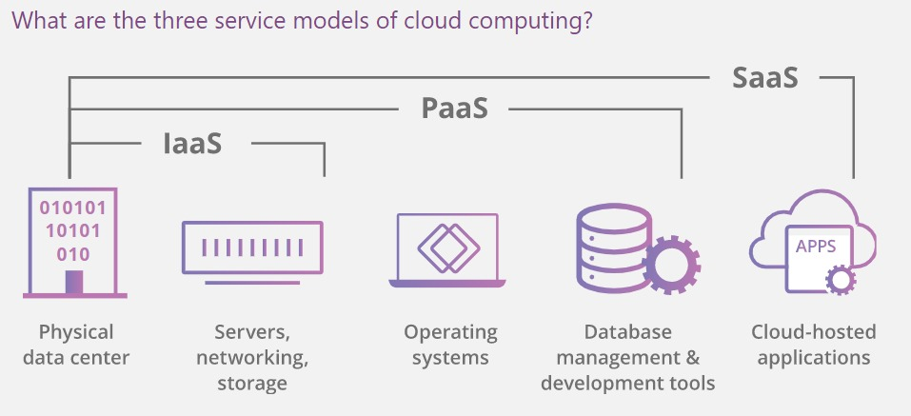

* **The main offerings included by PaaS vendors are:**
* Development tools:

PaaS vendors offer a variety of tools that are necessary for software development, including a source code editor, a debugger, a compiler, and other essential tools. These tools may be offered together as a framework. The specific tools offered will depend on the vendor, but PaaS offerings should include everything a developer needs to build their application.

* Middleware

Platforms offered as a service usually include middleware, so that developers don't have to build it themselves. Middleware is software that sits in between user-facing applications and the machine's operating system; for example, middleware is what allows software to access input from the keyboard and mouse. Middleware is necessary for running an application, but end users don't interact with it.

* Operating systems

A PaaS vendor will provide and maintain the operating system that developers work on and the application runs on.

* Database management

PaaS providers administer and maintain databases. They will usually provide developers with a database management system as well.

* Infrastructure

PaaS is the next layer up from IaaS in the cloud computing service model, and everything included in IaaS is also included in PaaS. A PaaS provider either manages servers, storage, and physical data centers, or purchases them from an IaaS provider.

* Different vendors may include other services as well, but these are the core PaaS services.
* **PaaS Types:**
* Application Delivery-only environments
* Stand-Alone development environment
* open platform as Service
* Add-on Development facility
* **Advantages of PaaS:**

1.Faster time to market

2.One environment from start to finish

3.Price

4.Ease of licensing

5.Continuous updates — PaaS experts perform all the necessary updates and you get them automatically.

6.Scalability — a default scaling mechanism can automatically release additional resources for your needs.

* **Drawbacks of PaaS:**

1.Vendor lock-in

2.Vendor dependency

3.Security and compliance challenges

4.Data security

5.Integration

6.Vendor lock in

7.customization of legacy sys

8.Runtime error

* **For Example:**

AWS Elastic Beanstalk, **Windows** Azure, Heroku, [Force.com](http://Force.com/), Google App Engine, Apache Stratos, OpenShift